CCNA 2 Lab 1.5.1
Instructions: Download Lab 1.5.1 PacketTracer activity from Moodle.
Configure the network devices with the IP settings shown in Table 1.

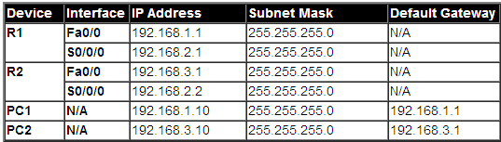
Table 1:
Connect the Network devices according to the following network topology shown in Figure 1

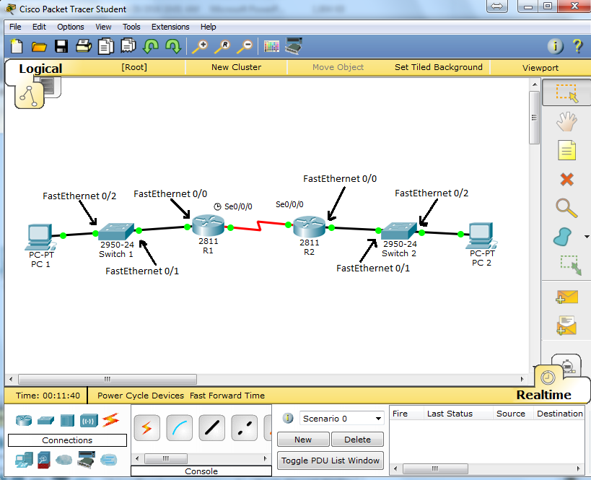
Figure 1: Network topology for 1.5.1

Task | Specification
Router name | R1 and R2
R1 interfaces | - set the description  - set IP address and Mask from table 1
R2 interfaces | - set the description  - set IP address and Mask from table 1
PC1 and PC2 interfaces | set appropriate IP address and Mask from table 1
R1 Static route | Configure static route that allow communication between the 192.168.1.0/24 and 192.168.3.0/24  Use R2 S0/0/0 as next hop IP,  Use distance-metric 10
R2 Default Static route | Configure static default route that allow communication between the 192.168.3.0/24 and any network  Use R2 s0/0/0 as exit interface

Router Commands
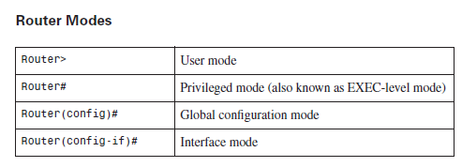
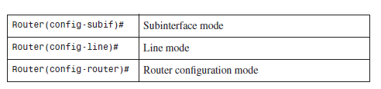
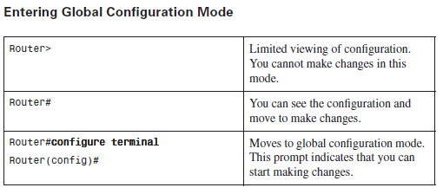

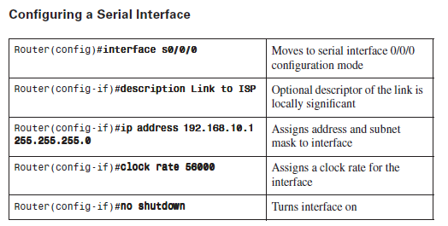
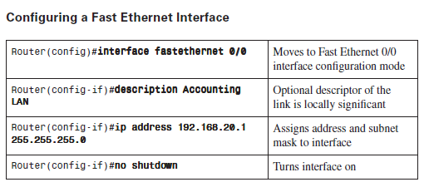
Configure a static route
Router(config)# ip route network-address subnet-mask {ip-address | exit-interface } distance-metric

